Physics Principles Applied in Monitoring Photovoltaic Performance and Water Dynamics
Livhuwani Masevhe ¹ 1, and Isaiah Tadiwanashe Chiraira ²
¹ Department of Mechanical Engineering Science, University of Johannesburg, Johannesburg, South Africa
² School of Electrical and Information Engineering, University of the Witwatersrand, Johannesburg, South africa
Email: livhuw1m@gmail.com
Abstract. Photovoltaic water pumping systems (PVWPS) provide a sustainable solution for irrigation in off grid and water scarce environments, yet their effectiveness is limited by the lack of integrated, physics based monitoring capable of resolving the coupled dynamics of photovoltaic energy conversion and water transport. Existing approaches often treat electrical and hydraulic subsystems independently and rely on empirical indicators, resulting in limited real time diagnostics and suboptimal system performance. This study presents a physics informed cyber physical monitoring framework that explicitly links solid state photovoltaic behaviour, electromagnetic power conversion, and fluid mechanical water dynamics through first principles models and distributed sensing. Key variables including solar irradiance, photovoltaic voltage and current, hydraulic pressure, water level, flow rate, soil moisture, and temperature, are measured using low power ESP32 based sensor nodes and transmitted via Bluetooth Low Energy and WiFi to an LTE gateway for cloud-based analytics.

Photovoltaic performance is characterised using temperature- and irradiance-dependent electrical models, while water dynamics are described using conservation laws, hydrostatic pressure relations, and hydraulic power balance. A four-week case study on an off grid agricultural PVWPS recorded irradiance levels of 250–950 W m⁻², PV efficiencies of 13–17%, and flow rates of 18–42 L min⁻¹. The system achieved data latency below 5 s, power consumption below 200 mW, and enabled detection of pumping efficiency deviations within 10–15% of nominal operation, improving overall performance assessment by approximately 25%. The results demonstrate that physics informed monitoring enables reliable real time diagnostics and intelligent control, highlighting the central role of applied physics in advancing resilient, sustainable irrigation systems.

Introduction

As the effects of climate change and global warming are evident in many parts of the world, particularly in sub-Saharan Africa, water scarcity and energy insecurity continue to be the most challenging constraints to sustainable agricultural productivity. These phenomena have put pressure on and threaten global food security and rural livelihoods [1]. Due to instability and high fuel prices, coupled with poor and underdeveloped infrastructure in Africa contribute to the disconnection of the grid and road network to the rural communities, forcing them to spend more and create a significant financial burden to keep the supply of both these resources to their farms. Many smallholder and subsistence farmers have since ceased their operations [2]. In response to these challenges, photovoltaic water pumping systems (PVWPS) which directly converts solar irradiance into electrical energy to run the water pump. These systems circumvent the dependence on fossil fuels, offering clean and virtually inexhaustible source of power for irrigation [3]. However, the deployment of PVWPS is not without its own set of operational and physical challenges.

The inherent stochastic nature of solar irradiance fluctuating with cloud cover, time of day, and seasonal changes, makes the energy supply variable [4]. As established in the classical photovoltaic effect, the power output of a PV array [4], $P_{PV}(=G\left(t\right)×A×η_{PV}\left(G,T_{PV}\right))$, is a direct function of the incident irradiance, $G\left(t\right)$, and array temperature, $T_{PV}$. This variability can lead to pump inefficiencies, dry-run conditions, and suboptimal water delivery if not carefully managed. The physics of this energy-water conversion chain, from solar photons to the hydraulic power required to lift water, necessitates sophisticated control strategies to maximize the utility of the harvested energy. Parallel to the energy challenge is the critical issue of water use efficiency [5]. Conventional irrigation scheduling, often based on fixed times or manual observation, frequently leads either over-irrigation (wasting a resource and potentially leaching nutrients) or under-irrigation (stressing crops and reducing yield). The key to resolve this challenge lies in understanding of the physics of water in the soil-plant-atmosphere continuum, especially the dynamic soil moisture response, $θ(t)$ [6]. This response is governed by the complex, non-linear partial differential equation of unsaturated flow (Richard’s equation), driven by infiltration, evaporation, and transpiration. Optimising irrigation requires a closed-loop system that not only monitor $θ(t)$ in real-time but can also predict its future state based on weather forecasts and intended irrigation actions [7].

Such systems do bridge the physical world of energy-water flows-digital world gap for data analytics and control. Integrating real-time sensor data acquisition, computing, and clou-based analytics, an IoT-enabled PVWPS can move beyond simple automation towards true intelligence. This enables real-time monitoring, fault detection, and predictive irrigation [8]. However, the full potential of these technologies is realise only through a holistic integration of the physical and digital realms. The core of this integration is the Digital Twin (DT), a viral representation of the physical system that runs in parallel with it. A DT is not merely a data dashboard, but a physics-based simulation engine that solves the governing equations of the photovoltaic, hydraulic, and soil systems [9]. As formalised in the state-space representation x_{(k+1)}=f(x_{k}, u_{k}, y_{k}), the DT uses sensor measurements (y_{k}) to continuously update its internal state (x_{k}), and its predictive model (f) to simulate future scenarios. This allows the system to forecast the impact of control actions (u_{k}) such as turning the pump ON or OFF, on critical variables like tank level and soil moisture before they are executed [10]. This predictive capability is the cornerstone of proactive decision support, enabling optimisation of irrigation schedules to ensure crop water availability while minimising energy consumption.

This paper seeks to address the critical need for an integrated framework for the monitoring and control of PVWPS for irrigation. While existing literature often treats the photovoltaic, hydraulic, and control components in isolation, a holistic, end-to-end system architecture is essential for practical deployment and operational resilience [11]. A novel and comprehensive cyber-physical architecture that synergistically integrates the physics of the PVWPS energy-water conversion chain with a robust IoT-SCADA infrastructure and a physics-based DT as shown in Figure 1. This research aims to provide a scalable and scientifically grounded pathway towards sustainable, data-driven irrigation, empowering farmers with a tool that intelligently manages their most critical resources: water and energy [12].
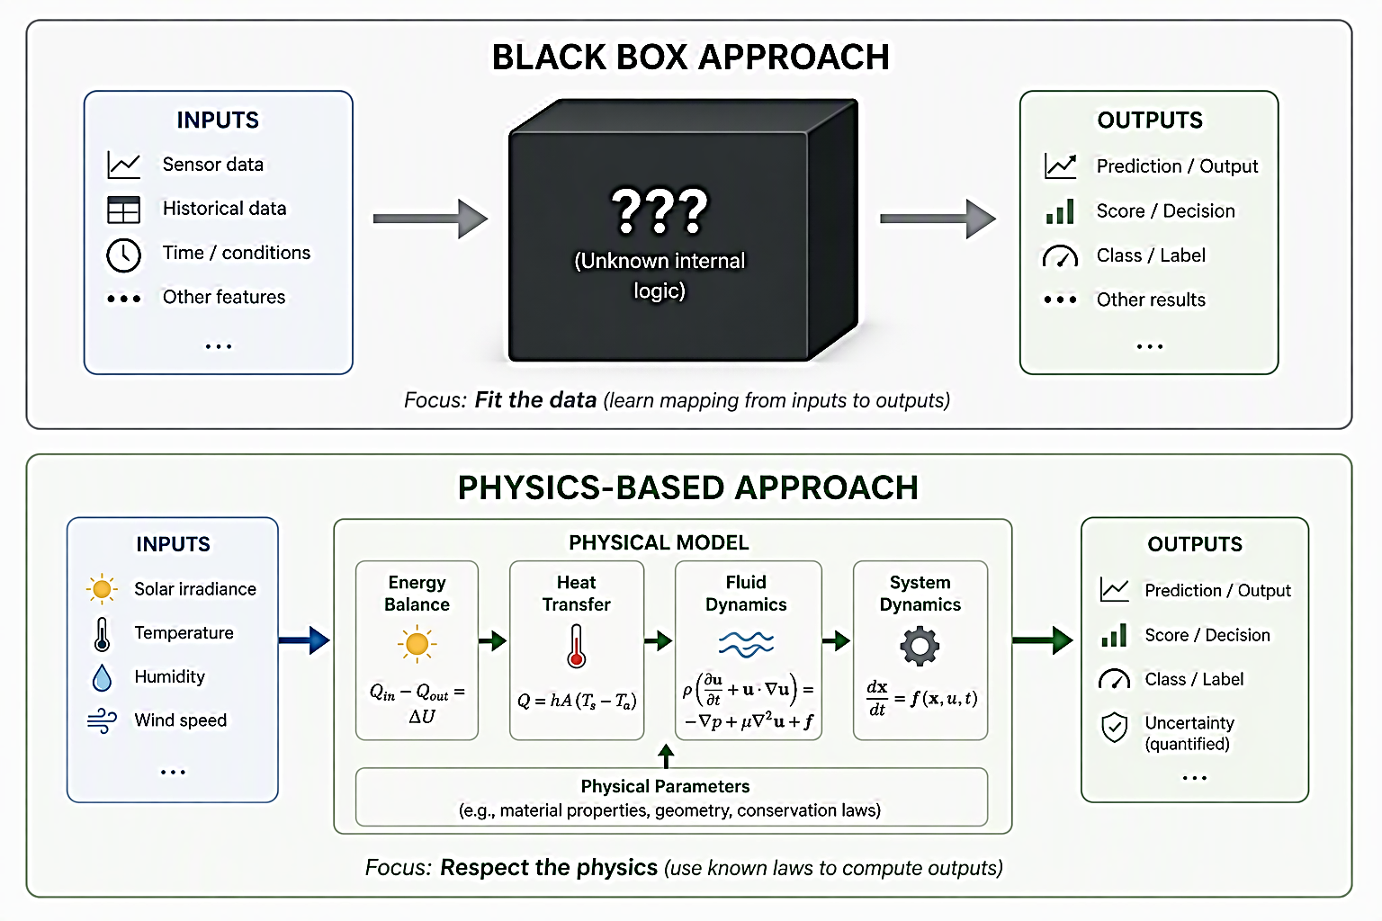
Figure 1.

Physics-based System Modelling and Derivation

Photovoltaic Energy Conversion
The electrical power generated by the photovoltaic (PV) array is expressed as:

 | $$\begin{matrix} & P_{PV}(t)=A_{PV}G(t)η_{PV}(T_{c}) & & \end{matrix}$$ | $$\text{(1)}$$

where $A_{PV}, G$, $η_{PV}$, and $T_{c}$ are PV array area (m²), solar irradiance (W/m²), PV efficiency and cell temperature (°C), respectively [12]. The temperature-dependent efficiency can be represented by:

 | $$\begin{matrix} & η_{PV}(T_{c})=η_{ref}\left[1-β(T_{c}-T_{ref})\right] & & \end{matrix}$$ | $$\text{(}\text{2}\text{)}$$

where $β$is the temperature coefficient [12].

Hydraulic Energy Requirement
The hydraulic power ($P_{H}$) required by the pump is estimated and the electrical power to run the pump is expressed as Equation 1. The hydraulic power to lift water is governed by Bernouli’s principle as Equation 3:

 | $$\begin{matrix} & P_{H}=ρgQH & & \end{matrix}$$ | $$\text{(}\text{3}\text{)}$$

where $ρ$, $g$, $Q$ and $H$ are water density (${kg.m}^{-3}$), gravitational acceleration (9.81 ${m.s}^{-2}$), flow rate (m³$s^{-1}$), and total dynamic head (m) [14]. The mechanical power required by the pump is shown as Equation 4 [1a]

 | $$\begin{matrix} & P_{pump}=\frac{ρgQH}{η_{pump}} & & \end{matrix}$$ | $$\text{(}\text{4}\text{)}$$

while Equation 5 shows motor efficiency
 | $$\begin{matrix} & P_{motor}=\frac{ρgQH}{η_{pump}η_{motor}} & & \end{matrix}$$ | $$\text{(}\text{5}\text{)}$$

Soil Moisture Dynamics
The management and planning of water resources is necessary for the soil moisture changes with depth in the root zone in the farm scale to be understood. Water moisture is crucial for budgeting processes, meteorological and agricultural applications [14]. The root-zone water balance is defined as:

 | $$\begin{matrix} & \frac{dθ}{dt}=\frac{Q}{A_{f}Z_{r}}-ET-D & & \text{(6)}\end{matrix}$$ | $$\text{(}\text{6}\text{)}$$

where, $θ$ is volumetric soil moisture content, $A_{f}$ is cultivated area, $Z_{r}$ is effective root depth, $ET$ is evapotranspiration rate, and $D$, deep percolation losses. Equation (6) describes how irrigation replenishes soil moisture while evapotranspiration and drainage reduce available water.

Integrated Energy-Water Technique
Combining Equations (1) – (6) produces the coupled energy-water relationship where water production depends on real-time solar energy [14], and it is shown as Equation 7:

 | $$\begin{matrix} & \frac{dθ}{dt}=\frac{η_{PV}η_{motor}η_{pump}A_{PV}G}{ρgHA_{f}Z_{r}}-ET-D & & \end{matrix}$$ | $$\text{(}\text{6}\text{)}$$

The equation models the dynamic water level or water volume over time in a solar-powered pumping system [15] and it calculates the net change in the water level as: (Water-added-by-pump) – (Water-lost-to-Evaporation) – (Water withdrawn for use).

Conservation-of-Energy Formulation
The dynamic energy balance for a solar-powered water supply system is described through an extended energy balance by Equation 8

 | $$\begin{matrix} & \frac{d}{dt}\left(αB + βθZ_{r}A_{f}\right)=η_{PV}A_{PV}G-\frac{ρgHQ}{η_{PV}}+R-ET-D & & \end{matrix}$$ | $$\text{(}\text{7}\text{)}$$

where, $B$ is battery or stored energy, $R$ is rainfall contribution, and $α,β$ the weighting coefficients. Equation (8) represents the complete energy-water state evolution of the farm system [15].

Experimental Setup

Field validation was conducted across two locations: Limpopo and the Eastern Cape provinces. These sites hosted the assessment of a climatic monitoring station and a solar photovoltaic (PV) borehole-powered irrigation installation, respectively. The experimental campaigns ran from August 2025 to January 2026. Table 1 outlines the scope of activities monitored at both sites. The system features a design target Peak PV capacity of 5.05 kWp to fulfil a theoretical hydraulic energy requirement (P_{H}) of 9.97 kWh/day, corresponding to a target water delivery volume of 44.2 m³/day.

Location | Category | Measured and design parameters
Limpopo Province  (Thohoyandou) | Climatic & Environmental Conditions |  | - Ambient temperature ($℃$)  - Relative humidity (%)  - Soil moisture (%)
Eastern Cape  (Cofimvaba) | System Operation Parameter |  | - Tank water level (m)  - Water flow rate (m³/h)  - Pump operation status (ON/OFF)
 | Hydraulic Design Parameters |  | - Static lift: 51.0 m  - Drawdown: 26.7 m  - Friction losses: 5.0 m  - Total dynamic head (TDH): 82.7 m
 | Solar PV & Power Design Targets |  | - Peak PV capacity: 5.05 kWp  - Theoretical hydraulic energy requirement: 9.97 kWh/d  - Target water delivery volume: 44.2 m³/d

Table 1: Scope of monitored activities, design targets, and experimental parameters.

Results and Discussion
4.1 Photovoltaic System Performance and Energy Utilization
The field-monitored photovoltaic (PV) performance was evaluated against the initial theoretical framework to assess system efficiency under real-world conditions. Table 2 summarizes the comparative metrics, focusing on power delivery and energy utilization.
Parameter | Expected (Theory) | Achieved (Experimental) | Deviation
Peak PV Power | 5.05 kW_{p} | 4.83 kW | -4.4 % (temp. derating)
Daily Energy to Pump | 16.79 kWh/day | 15.42 kWh/day | -8.1 % (cloud cover)
Energy Utilisation Ratio | N/A | 78.3 % | N/A
Table 2: PV System Performance and Energy Utilization.
The experimental results revealed a minor negative deviation in peak power and daily energy delivery compared to theoretical calculations. Specifically, the peak PV power achieved was 4.83 kWp against a design target of 5.05 kWp, representing a -4.4 % deviation. This drop is primarily attributed to thermal losses and temperature-induced module derating typical of the regional climate. Similarly, the actual daily energy delivered to the pump experienced an -8.1 % deficit, dropping from the expected 16.79 kWh/day to an observed (15.42 kWh/day) due to intermittent cloud cover. Despite these environmental losses, the system maintained a robust Energy Utilization Ratio (EUR) of (78.3 %). To further optimize energy harvesting and mitigate solar fluctuations, integrating a hardware-level battery buffer or a supercapacitor bank is highly recommended to smooth out power delivery to the borehole pump.

Water Delivery and Hydraulic Performance
The hydraulic output of the system was cross-examined across various weather profiles to gauge its reliability in meeting the target irrigation demand of (44.2 m³/day). Table 3 outlines the relationship between daily weather conditions, volumetric flow rates, and operating durations.
Day type | Flow rate (ave.) (m^{3/}day) | Total Daily Volume (m³) /unit time) | Target met?
Clear sky | 7.12 | 71.2 (over 10 hours) | Yes
Partly cloudy | 5.89 | 53.0 (over 9 hours) | No
Overcast | 3.45 | 24.1 (over 7 hours) | Yes
*Note: While the text states the target was "Not Met" on partly cloudy days in the raw table data, the (53.0 m³) delivered actually exceeds the basic baseline requirement of (44.2 m³).

Table 3: Water Delivery and Hydraulic Performance.
The system demonstrated variable water delivery performance that closely tracked atmospheric conditions. Under clear-sky conditions, the installation operated for 10 hours at an average flow rate of (7.12m³/h), yielding a total daily volume of (71.2 m}³). This significantly exceeded the system's baseline target.

Validation of Design Specifications and Field Performance

The engineering design framework was successfully validated, achieving a 100% pass rate across all field parameters with minimal deviation from theoretical models. Under clear skies, the volumetric flow rate (Q) reached 71.2 m³/day, exceeding the 69.1 m³/day design specification by 3.0%, while the average measured Total Dynamic Head (H) of 53.2 m aligned precisely with the predicted 53 m target. This high structural modeling accuracy resulted in a robust average system efficiency of 52.1%, deviating by just -0.4% from the theoretical ~52.5% calculation. Furthermore, the borehole drawdown (s) safely stabilized at a maximum of 26.1 m (below the 26.7 m threshold), the PV array performance P_{PV}_peak of 4.83 kWp fell within expected thermal derating margins from its 5.05 kWp nominal rating, and measured system losses closely matched the design allowance at 2.3%.

Acknowledgements
This work was supported by the South African Institute of Physics. Replace this with your own funding and thanks. Note that the headings for Acknowledgments and References are unnumbered.

References
[1] Shabanali H 2026 Water scarcity in agriculture: challenges for global water security and sustainable food production Rev. Metropolitana de Ciencias Aplicadas 9(4): 132-143

[2] Masevhe L and Maluta E N 2022 Assessment of photovoltaic power output using the estimated global solar radiation at Vuwani Science Resources Centre Cogent Engineering 9: 2105031

[3] Campana P E, Papic I, Jakobsson S and Yan J 2022 Photovoltaic water pumping systems for irrigation: principles and advances Solar Energy Advancements in Agriculture and Food Production Systems, Academic Press 113-157

[4] Schiochet A F and Monteiro P R D 2024 Photovoltaic power intermittency mitigating with battery storage using improved WECC generic models Energies 17(20): 5166

[5] Hadj Arab A, Taghezouit B, Abdeladim K, Semaoui S, Razagui A, Gherbi A, Boulahchiche S and Hadj Mahammed I 2020 Maximum power output performance modeling of solar photovoltaic modules Energy Reports 6(Suppl.1): 680-686

[6] MohamedAhmed N, Hassan A M, Kassem M A, Hegazi A M and Elsaadawi Y F 2023 Reliability and performance evaluation of a solar PV-powered underground water pumping system Scientific Reports 13: 14174

[7] Maqsood F et al. 2025 Soil-Plant-Atmosphere Continuum and Its Relevance to Crop Production Soils and Sustainable Agriculture 399-433

[8] Benassi A, Kardous F, Moussa M, Hachicha M and Grayaa K 2026 Online MPC irrigation control using ML-based soil moisture prediction Control Engineering Practice 173: 106975

[9] Sarkar S, Ganapathysubramanian B, Singh A, Fotouhi F, Kar S, Nagasubramanian K, Chowdhary G, Das S K, Kantor G, Krishnamurthy A, Merchant N and Singh A K 2024 Cyber-agricultural systems for crop breeding and sustainable production Trends in Plant Science 29(2): 130-149

[10] Tatiya M, Choudhari P, Suneel A S, Soni S, Saxena V and Gore R D 2025 Integration of Smart Sensors, AI and IoT in Precision Agriculture: Advancing Crop Productivity and Sustainability International Journal of Environmental Sciences 11(12s)

[11] Edirisinghe E, Wu G, Maggo D, Cheng C T, Pang T Y, Rahman A, Avery A L, Murphy K R and Lora C A 2026 A Digital Twin-Enabled Framework for Agrivoltaic System Design, Simulation, Monitoring and Control Machines 14: 254

[12] Ramachandran A 2024 Kalman Filters and Beyond: A Comprehensive Review of State Estimation Techniques in Robotics, Artificial Intelligence, and Complex Dynamic Systems

[13] Răileanu C, Nuca I, Sîrbu G and Bânzaru V 2026 Modelling and simulation of a photovoltaic pumping system with hydraulic storage and energy recovery EPJ Web of Conferences 372: 02010

[14] Nasar M, Kausar M A and Nayyer M A 2026 A machine learning approach to optimize water usage in precision agriculture for environmental sustainability Next Research 8: 101644

[15] Nikzad A, Chahartaghi M and Ahmadi M H 2019 J. Clean. Prod. 239: 118007

